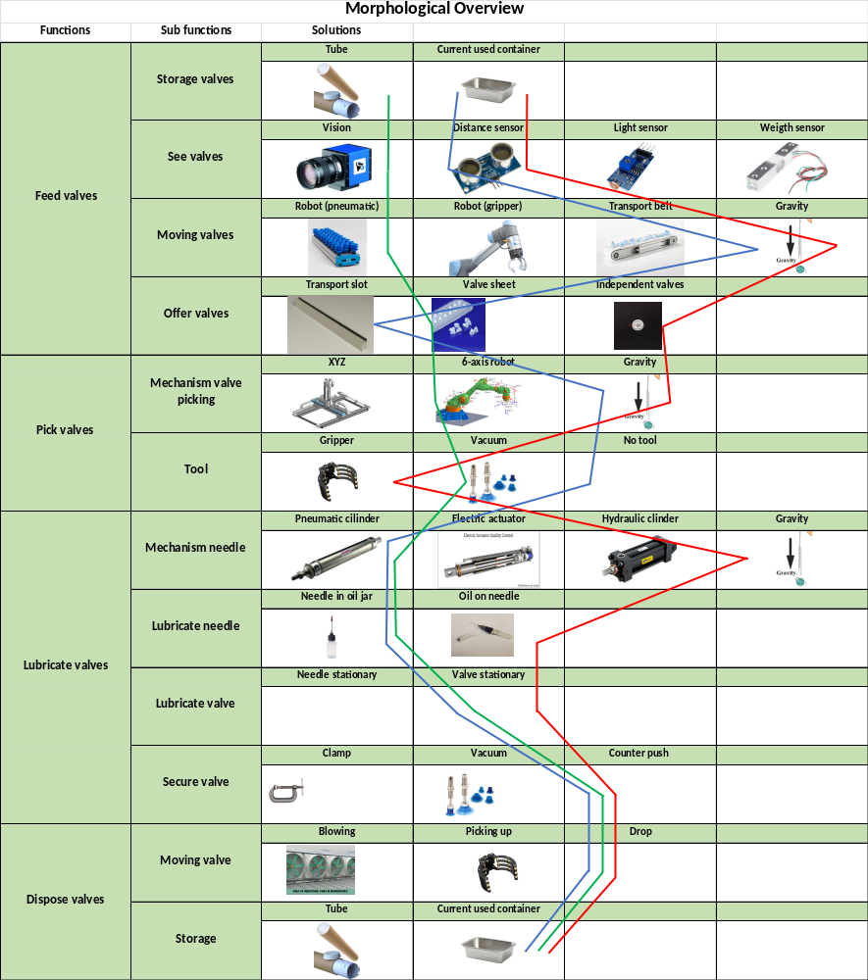
Morphological overview description
Figure 1 Morphological overview

Most realistic solution
Cheapest solution
Best functional solution

To create a concept, a morphological overview is used. In this overview there will be multiple solutions per function. Using this overview three concepts will be created; a blue line: this is the most realistic concept; a red line: this is the cheapest solution; a green line: this is the best functional solution. In Figure 1 the morphological overview with these three lines is visible.
The three concepts are shown below, each function with its own solution.

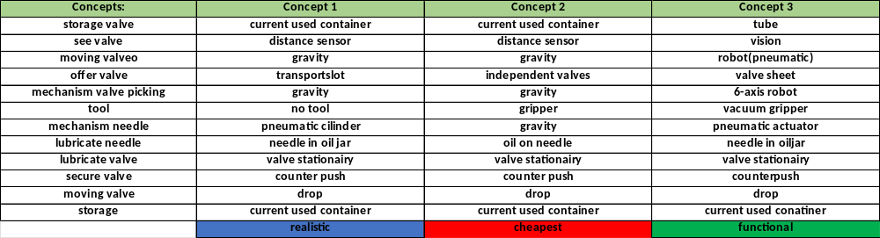
Figure 2 Different concepts
In Figure 2 the 3 made concepts (see also the 3 lines in Figure 1) are visible each with a solution per function. The three concepts are individually described below.

Concept 1 (realistic):
This concept is the most realistic one out of the 3 concepts. The parts that are able to be chosen cheap are simplistic. The parts where more sophisticated equipment is needed include the more expensive parts for precision and accuracy.
The current storage containers will be used, which will be flipped so the valves will fall into a transport slot and will be rolling towards the lubricating station. The needle will be lubricated by drowning itself in the CMT-oil. The valve will be stationary during lubrication. After lubricating the valve will be loosened from the needle with a counter force so it will separate from the needle and will consequently fall into another existing storage container.

Concept 2 (cheapest):
This concept contains the cheapest yet functional solutions.
We start with using the current container for the storage of the valves, to detect if there are valves located in the machine the cheapest solutions is a distance sensor. To pick up the valves and move them, the solution for this concept is to combine gravity together with a single valve. There also will be a gripper to help pick up the valve.
To lubricate the valve, the needle needs to be lubricated. In this concept the needle will be used the same as current by dipping in an oil jar. Thereafter the needle will move to the valve and penetrate the valve that is secured by a counter push mechanism.
Then the valve will be let go and the gravity will drop it in the end container, which is the same as the current situation.

Concept 3 (functional):
This concept contain the most functional solutions. Focusing on practical applications rather than cost or feasibility.

The valves will be presented in a tube, the tube will, with assistance from the machine, be able to consistently dispense sheets of valves. These valves will pass by a vision system to detect the orientation of the sheet. A pneumatic robot will pick the sheets up with a vacuum gripper. The robot will put the sheet below a pneumatic actuator, the pneumatic actuator will lubricate the valves with a lubricated needle. The needle will be oiled between valves. The lubrication of the needle will happen by putting the needle in a jar with CTM oil. To secure the valves while lubricating the needle will have casing that pushes down on the valves to keep them secured while lubricating. After lubricating the valves will be dropped in a container.

See the description for each function in the SRD.

